$50 for a photo!

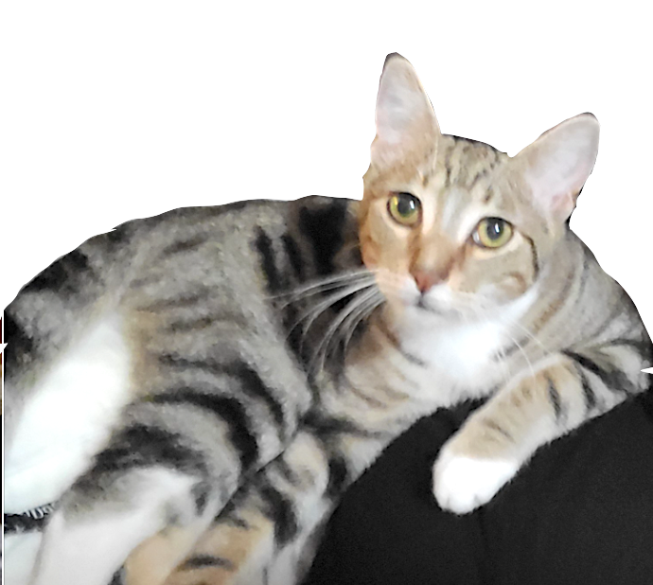

…IF confirmed as our missing cat. If seen

please DO NOT CHASE!

just call or text a photo to:
404.996.0116
$ for a photo!

Replace this box with a closely cropped side view photo of your cat
ideally with the background silhouetted out so your cat’s shape and markings are clear at a glance.

…IF it is confirmed as our missing cat. If seen...

please DO NOT CHASE!

just call or text a photo to:
xxx.xxx.xxxx

